Oregon Joint Use Association
Standards Committee
Meeting Minutes
October 21, 2009

The meeting was called to order at 10:08 a.m.

Members Present
Tamara Johnson, Chair, Springfield PUD
Jim McGuire, PGE
Stan Cowles, Qwest
Scott Wheeler, Comcast
Gary Putnam, OPUC
John Wallace, OPUC
Bill Kraxberger, PGE
Jeff Liberty, Bend Broadband*
*via teleconference

OJUA Staff
Genoa Ingram

Members Not Present

Dave Chaney, Accent Inc.
Jim Corwin, Verizon
Jim Flu, PacifiCorp
Scott Jennings, Verizon
Gary Payne, Qwest
Rob Kolosvary, PGE
Mark Simonson, Utility Consultants

Approval of Minutes
The minutes of the July 8, 2009 meeting were approved as presented.

Accuracy Rate
The Committee reviewed and discussed the document relating to accuracy rates. (EXHIBIT A)

Motion: Moved by John Wallace and seconded by Stan Cowles to approve the Accuracy Rate document for presentation to the Board. Motion passed.

Climbing Space – NESC Interpretation
Jim McGuire reported that PGE staff would review the NESC records for interpretations on the “climbing space/boxing the pole” issue. John Wallace commented that rule 236 was clear and had not changed. Submission of a request for interpretation was discussed. Chair Johnson suggested that Jim coordinate with Bill Tierney. Gary Putnam questioned, given the sensitivity of fiber, why anyone would want workers climbing on cable. Further action on this issue is deferred pending further direction from the Board to go forward.

Loose Wires
Staff was asked to edit the loose wire exhibit (EXHIBIT B) to include language from the PUC Staff Comments as follows: “Vertical conductors should be attached at regular intervals not more than 24” apart. Additionally, all such attachments should be placed in the same quarter of the pole, when possible.”
Field Reference Cards
The Committee reviewed examples of Field Reference Cards submitted by Qwest, Springfield PUD, Comcast and PGE (EXHIBITS C-F). Staff was asked to obtain a sample from PacifiCorp. Jeff Liberty agreed to locate an electronic copy of Bend Broadband’s card and forward it to staff. The Committee decided that the Field Reference Card issue should be a single agenda item for the next meeting.

New Business
Chair Johnson noted that J.R. Gonzales had suggested that the OJUA might want to be involved in the review of the NESC code book reprints. She suggested that the Association, and specifically the Standards Committee, could identify those areas on which there was consensus and forward those comments to the NESC. The question was whether to wait for the Board to task the Committee with that project or to take the initiative and go forward.

Next Meeting
The next meeting was scheduled for November 18, 2009, 10:00 a.m.

Adjourn
There being no further business, the meeting was adjourned at 2:27 p.m.

EXHIBIT A

Discussion of “Accuracy” relating to Notices of Violations

Relevant Oregon Administrative Rules:

860-028-0115 *Duties of Structure Owners* (6) An owner must ensure the accuracy of inspection data prior to transmitting information to the pole occupant.

860-028-0170 *Plans of Correction* (1) A plan of correction must, at a minimum, set out:
(a) Any disagreement, as well as the facts on which it is based, that the pole occupant has with respect to the violations alleged by the pole owner in the notice;

Discrepancies of Data contained in Notice of Violation

- Notified entity is not located on the pole (nor required to attach)
- Stated violation does not exist
- Mis-identified facility in violation (e.g., TV drop is cut and hanging, not telephone)
- Code not properly applied to attachment (e.g., exceptions for communication drops over driveways attached to highest point of house only need 11’6”, not 15’ 6”)
- Pole cannot be located with information provided

Other discrepancies, which often require a pole inspection and response, but would not be considered an issue of “accuracy”:

- Another entity created the violation (disputed)
- Citing party does not own the pole
- Grandfathered attachments
- Communications spacing agreements (less than 12” separation at the pole, yet the parties have an agreement, which by code, is not a violation)
- Facilities on the pole have been modified since the inspection data was transmitted, and therefore a violation on Notice may not exist

October 14, 2008

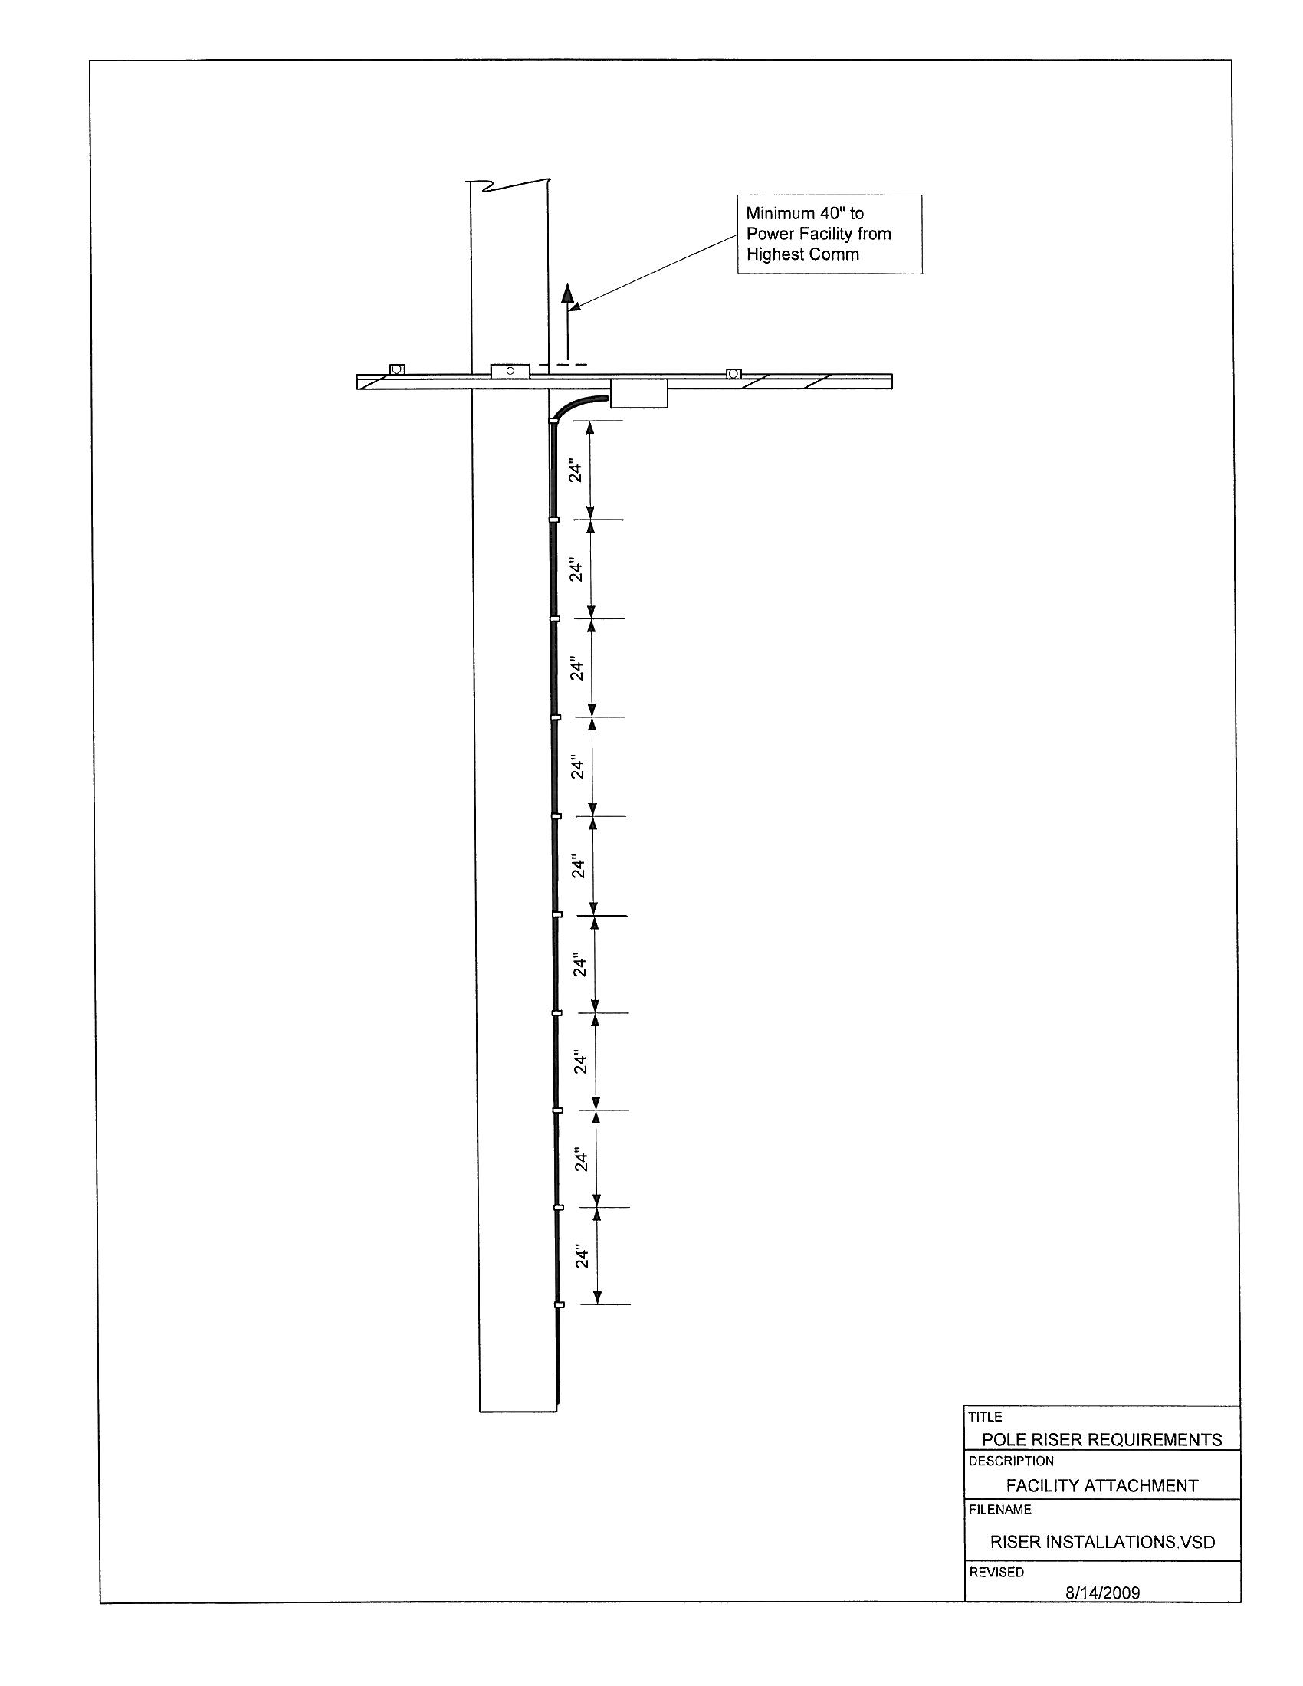

EXHIBIT B

Vertical conductors, not enclosed in conduit, should be attached at regular intervals not more than 24” apart. Additionally, all such attachments should be placed in the same quarter of the pole, when possible.

