Oregon Joint Use Association
Standards
Committee
Meeting Minutes
Wednesday, September 19, 2012

Chair Dan Wittmer called the meeting to order at 10:17 a.m.

Present

Dan Wittmer, Emerald PUD, Chair
Paul Birkeland, OPUC Staff
Corey Cook, Pacific Power
John Wallace, OPUC Staff
Bill Hamelman, Frontier
Scott Wheeler, Comcast

OJUA Staff
Genoa Ingram

Approval of Minutes
Motion: Moved by Corey Cook and seconded by Bill Hamelman to approve the minutes of the July 18, 2012 meeting as presented. Motion passed.

Old Business
Mapping: Chair Wittmer reported that he had would contact Dave Chaney regarding mapping.

Fire Hydrants: The Committee discussed a memo from Allen Clapp regarding fire hydrants. (EXHIBIT A) The Committee also reviewed a letter of notification for the fire service as prepared by PacifiCorp and agreed to recommend the concept of the fire hydrant letter to the Executive Committee as a possible standard of the OJUA

Grandfathering: Chair Wittmer reminded the Committee that the Standards Committee had been asked to give a presentation on the Grandfathering Matrix. Following discussion, Committee members agreed and Chair Wittmer will work with the P&E Committee on the specifics of the presentation. In the interim, PacifiCorp will create a generic version of the Matrix for distribution to Committee members, who are asked to forward additional examples for inclusion.

OPUC Time Frames: Chair Wittmer referenced the July discussion regarding PUC timeframes for correction. John Wallace noted that the original ALJ had referenced an A/ B/C priority system in the Order but had been silent on the matter in the rules. As a result, there was considerable confusion in the industry.

Next Meeting
The next meeting will be the third Wednesday, November 14 at 1:00 p.m. at Salem office.

Adjourn
There being no further business, the meeting was adjourned at 11:48 a.m.

DISTRICT NAME
ADDRESS
CITY, STATE ZIP
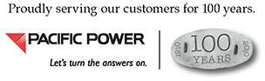
DATE
NAME
ADDRESS
CITY, STATE ZIP
RE: Improper Clearance from Supporting Structure to Fire Hydrant
National Electrical Safety Code Rule 231A
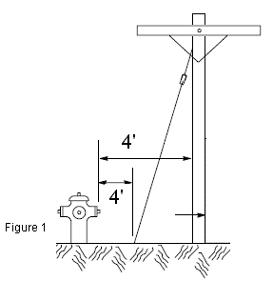
Dear Chief :
NESC Rule 231A provides fire department crews adequate space between a supporting structure (utility pole and/or guy) and a fire hydrant in order to connect hoses and fire equipment to the hydrant. The rule states that the clearance from a supporting structure to a fire hydrant shall not be less than 4’, (figure 1) but allows for a clearance of 3’ (Exception #1) where conditions do not permit 4’. Exception #2 of this rule also allows for lesser clearances provided there is an agreement between the local fire authority and the owner of the pole.
Our structure/pole ENTER MAP STRING ENTER FACILITY POINT located at or near ENTER ADDRESS OR LOCATION has a clearance of ENTER FEET AND/OR INCHES. We are requesting a variance for the existing clearance as provided for in Exception #2.
Should you wish to discuss our request please contact me at the number listed below. If you agree to the clearance variance of NESC 231A, please sign and date where indicated below and return this agreement to our offices in the enclosed envelope by ENTER DATE 14 DAYS FROM TODAY.
Thank you so much for your consideration. I look forward to either hearing from you or receiving this completed form back from you.
Sincerely,
NAME
DISTRICT

As the acting authority for the above referenced Fire District, my signature below verifies approval of the clearance variance for the above referenced structure/pole.
Signature Date
Printed Name and Title

